#### Cardiologic examination report

|  |  |
| --- | --- |
| καρτα2 | **Exam date** **: {{ date }}**  **---**  **Mr./Ms. {{ owner }}**  **« {{ petName }} »**  {{ breed }}  {{ sex }}, {{weight }} kg  Age: {{age}} |

**Dr. Theodoros SINANIS**

DVM, MSc, MRCVS

*Master of Science in Veterinary Internal Medicine,*

*Specially trained in Veterinary Cardiology at the*

*Cardiology Unit of Alfort, Paris- France*

*(École Nationale Vétérinaire d'Alfort)*

*European Society of Veterinary Cardiology member*

** Medical history – clinical examination**

**History :**

* Referring physician:**{% if referVet %}{{ referVet }}{% else %} -{% endif %}.**
* {{cardiologicalAnalysis}}{% if historic %}{% for moment in historic %}
* {{ moment }}{% endfor %}
* {% endif %}Radiographic examination: {{radiologicalChestAnalysis}}
* Cardiac medication so far: {% if medication %}{% for med in medication %} **{{med.medicationEngMenu}}** ({{med.doseNumber}} {{med.unitOfMeasurementMenu}} {{med.doseMenu}}),{% endfor %}{% else %} **None**{% endif %}**.**

**Clinical findings** :

* {% if rythm %}{{rythm}}{% else %}{% endif %}{% if auditoryFindings %}Cardiac auscultation revealed a {{auditoryFindings.systolicEngMenu}}, {{auditoryFindings.degreeEngMenu}}, {{auditoryFindings.auscultationEngMenu}} murmur, with a PMI at the {{auditoryFindings.auditoryEngMenu}}, {{auditoryFindings.heartEngMenu}} at the {{auditoryFindings.valveEngMenu}}. {% else %}
* Cardiac auscultation was unremarkable. {% endif %}
* {{auditoryLung}}
* {{cough}}
* {{heartRate}}
* {% if mucous %}{% if mucous**==**’ND.’ %}Mucous membranes: {{mucous}} {% else %}{{mucous}}{% endif %}{% endif %}
* {% if dental %}{% if dental **==**’ND.’ %}Dental calculus: {{dental}}{% else %}{{dental}}{% endif %}{% endif %}
* {{bodyWeight}}.
* {{lymph}}

 **Echocardiography exam results**

The examination was performed with cardiac single crystal phased array probes (P 2-9 & P 1-5 mHz).

{% if PDF %}

|  |  |  |  |
| --- | --- | --- | --- |
| **Παράμετροι** |  | **Παράμετροι** |  |
| RVDd | {% if PDF.RVDd %}{{PDF.RVDd}}{% else %}7.8{% endif %} mm | Ao Vmax | Vmax = {% if PDF.AoVmax %}{{PDF.AoVmax}}{% else %}1.01{% endif %} m/s |
| IVSd | {% if PDF.IVSd %}{{PDF.IVSd}} {% else %}10.4 {% endif %} mm | P Vmax | Vmax = {% if PDF.PVmax %}{{PDF.PVmax }}{% else %}0.84{% endif %} m/s |
| LVDd | {% if PDF.LVDd %}{{PDF.LVDd}} {% else %}27{% endif %} mm | Ant. mitral leaflet | 3.5 mm |
| PWd | {% if PDF.PWd %}{{PDF.PWd}}{% else %}10.2{% endif %} mm | Post. mitral leaflet | 2.5 mm |
| IVSs | {% if PDF.IVSs %}{{PDF.IVSs}} {% else %}13.1{% endif %} mm | Mitral E/A wave | {% if PDF.MitralE %}{{PDF.MitralE}}{% else %}0.75{% endif %}/{% if PDF.Awave %}{{PDF.Awave}} {% else %}0.82{% endif %}({% if PDF.MVEA %}{{ PDF.MVEA }}{% else %}0.91{% endif %}) |
| LVDs | {% if PDF.LVDs %}{{PDF.LVDs}}{% else %}15.5{% endif %} mm | DT | {% if PDF.DT %}{{PDF.DT }}{% else %}86{% endif %} ms |
| PWs | {% if PDF.PWs %}{{PDF.PWs }}{% else %}12.6{% endif %} mm | RA/LA | 0.9 |
| FS | {% if PDF.FS %}{{ PDF.FS }}{% else %}43{% endif %} % | Mit.reg. Vmax | {% if PDF.MRVmax %}{{PDF.MRVmax }}{% else %}-{% endif %} m/s |
| LA- Ao | {% if PDF.LA %}{{PDF.LA}}{% else %}19.7{% endif %}-{% if PDF.Ao %}{{PDF.Ao}}{% else %}12.5{% endif %} mm | Tric. reg. Vmax | {% if PDF.TRVmax %}{{PDF.TRVmax }}{% else %}-{% endif %} m/s |
| LA/Ao | {% if PDF.LAAo %} {{PDF.LAAo}} {% else %}1.58{% endif %} | PT/Ao | 1 |

{% else %}

|  |  |  |  |
| --- | --- | --- | --- |
| **Parameters** |  | **Parameters** |  |
| RVDd | 8.6 mm | Ao Vmax | Vmax = 1.06 m/s |
| IVSd | 11.7 mm | P Vmax | Vmax = 0.85 m/s |
| LVDd | 38.9 mm | Ant. mitral leaflet | 3.5 mm |
| PWd | 10.3 mm | Post. mitral leaflet | 2.8 mm |
| IVSs | 15.8 mm | Mitral E/A wave | 0.6/0.76 (0.79) |
| LVDs | 29.6 mm | DT | 78 ms |
| PWs | 11.4 mm | RA/LA | 0.9 |
| FS | 24 % | Mit. reg. Vmax | - m/s |
| LA- Ao | 30.1-22.7 mm | Tric. reg. Vmax | - m/s |
| LA/Ao | 1.32 | PT/Ao | 1 |

{% endif %}

## Interpretation

Περιγραφή: Περιγραφή: ac387 **Right parasternal and transventricular short-axis view (m-mode):**

* Normal end-diastolic LV dimensions & normal end-systolic dimensions.
* The contractility of the LV is WNL.
* Normal right ventricular dimensions.

Περιγραφή: Περιγραφή: ac387 **Left atrium examination presents:**

* The left atrial dimensions are normal at the end-systole.
* No regurgitant volume through the mitral valve, on colour flow Doppler examination.

Περιγραφή: ac387 **Right parasternal and transaortic short-axis view:**

* No anatomic lesions were found at the level of the pulmonary annulus.
* Normal pulmonic flow.
* No pulmonic regurgitation is present.

Περιγραφή: ac387 **Right parasternal long-axis four & five chamber views:**

* Normal mitral valve (anterior & posterior leaflet) appearance.
* Normal right atrial dimensions.
* Normal right to left atrial ratio.
* No aortic regurgitation is present.
* No interventricular nor interatrial septal defect was found.

Περιγραφή: ac387 **Left parasternal long-axis four & five chamber views:**

* Luminar aortic flow at the level of the aortic annulus.
* {% if flow %}{{ flow |e}}{% else %}Normal transmitral flow velocity.{% endif %}
* No tricuspid regurgitation is present on colour-flow Doppler

Περιγραφή: Περιγραφή: ac387 **Other points:**

* No pericardial nor pleural effusion is present.
* No pulmonary hypertension is present.
* Sinus rhythm {% if ecg %}({{egc}}){% else %}**(sinus tachycardia)**{% endif %} during the examination. Heart rate: 92 bpm.

### Conclusions

* **Normal heart and great vessels** **appearance**{% if AddOn %} and {{AddOn}}{% else %}{% endif %}.

{% if medication2 %}

* **Cardiac medication**: {% for med2 in medication2 %}

1. **{{med2.medication2EngMenu}}** ({{med2.doseNumber}} {{med2.unitOfMeasurementMenu}} {{med2.doseMenu}}) {% endfor %} {% else%}

* **Cardiac medication :** not recommended.

{% endif %}

{% if checkUp %}

A 2nd echocardiographic examination is recommended after {% for che, months, years in checkUp %}{{che}} months (**{{months}} {{years}}**) {% endfor %}{% else %}{% endif %}

**Yours sincerely:**

**Dr. Theodoros Sinanis**

[**theodsin@hotmail.com**](mailto:theodsin@hotmail.com)

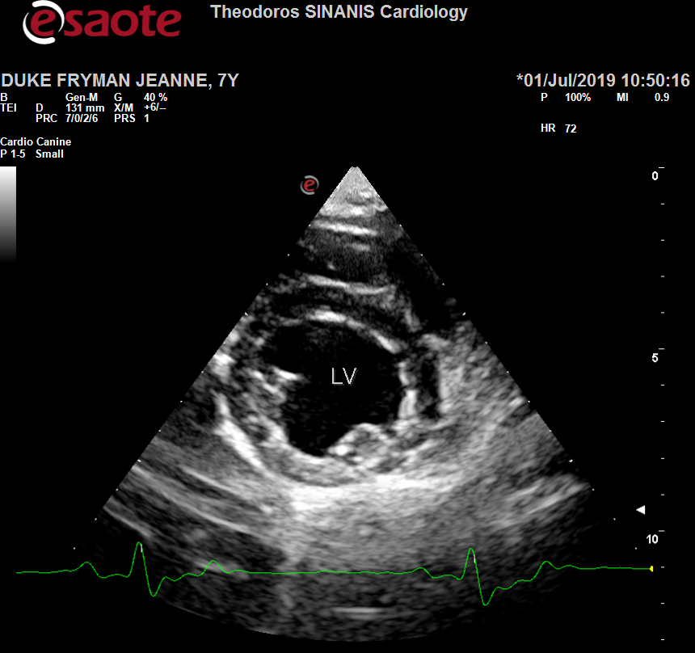 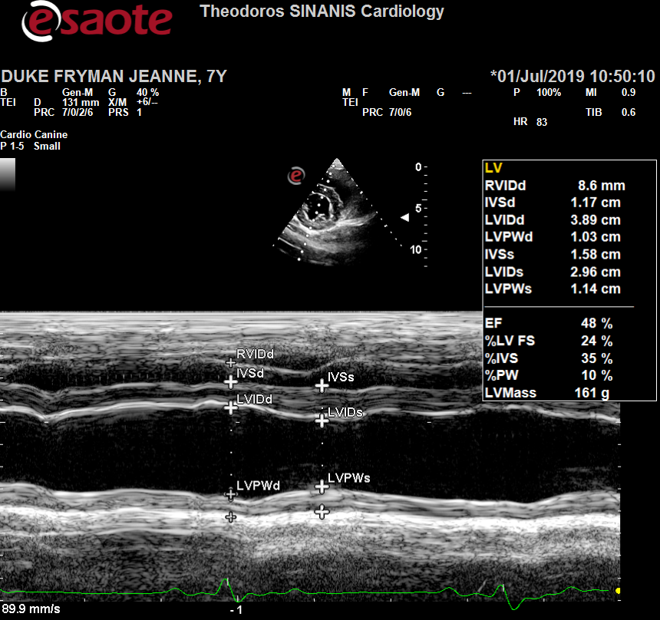

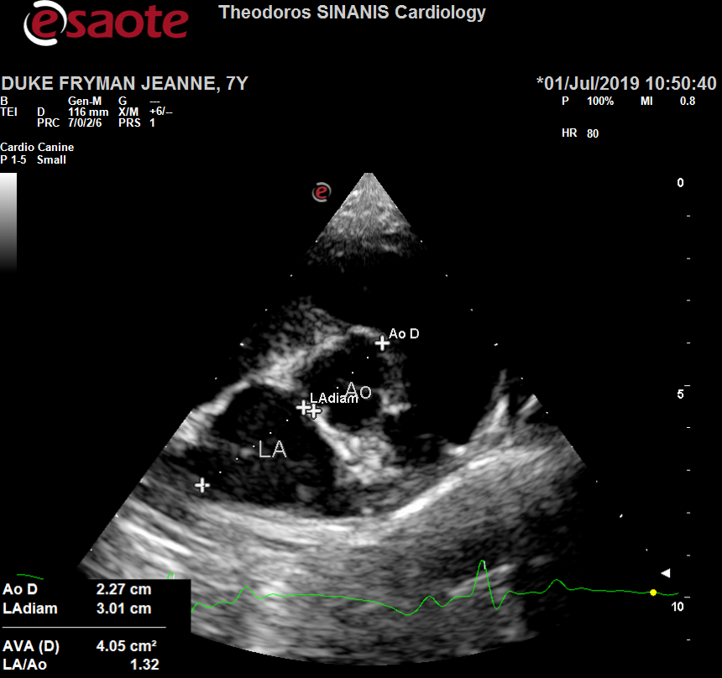 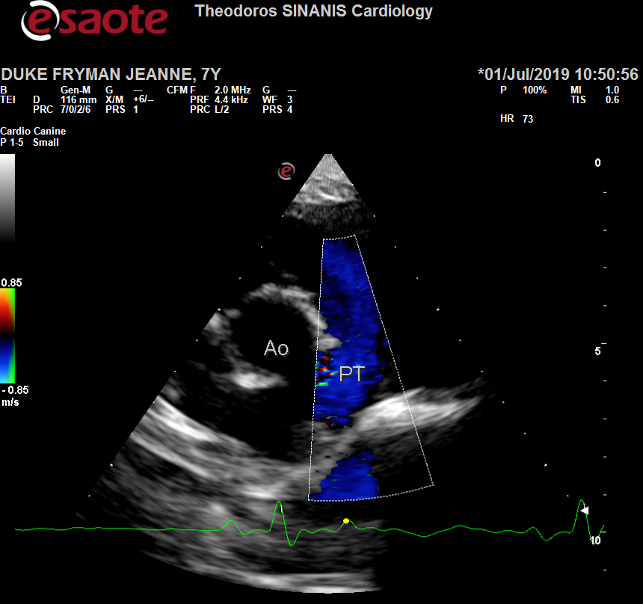

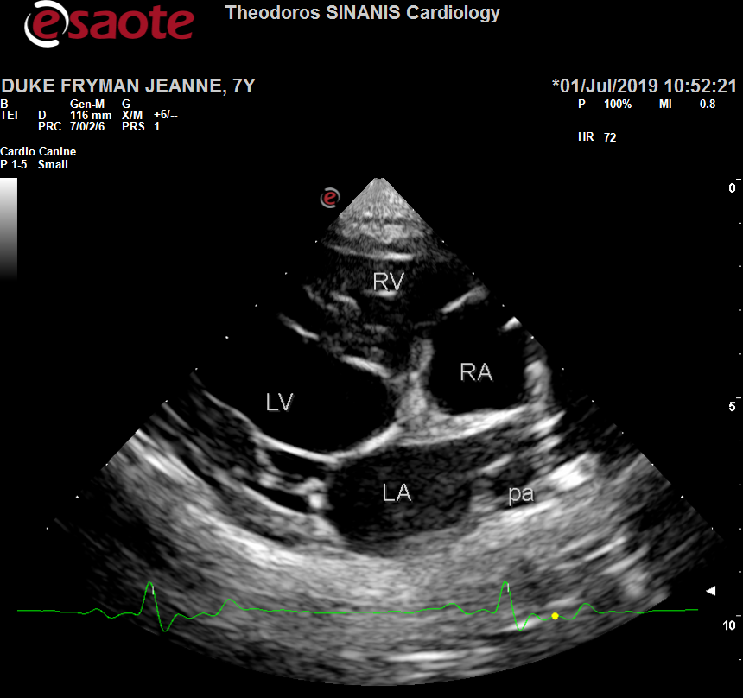 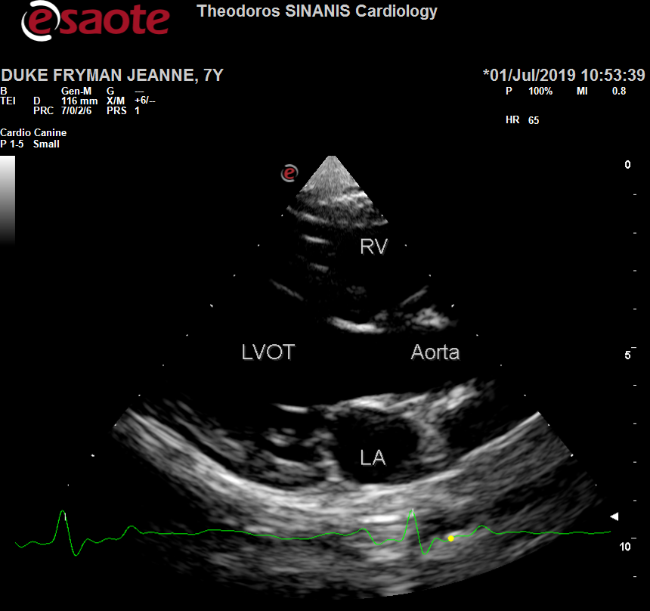

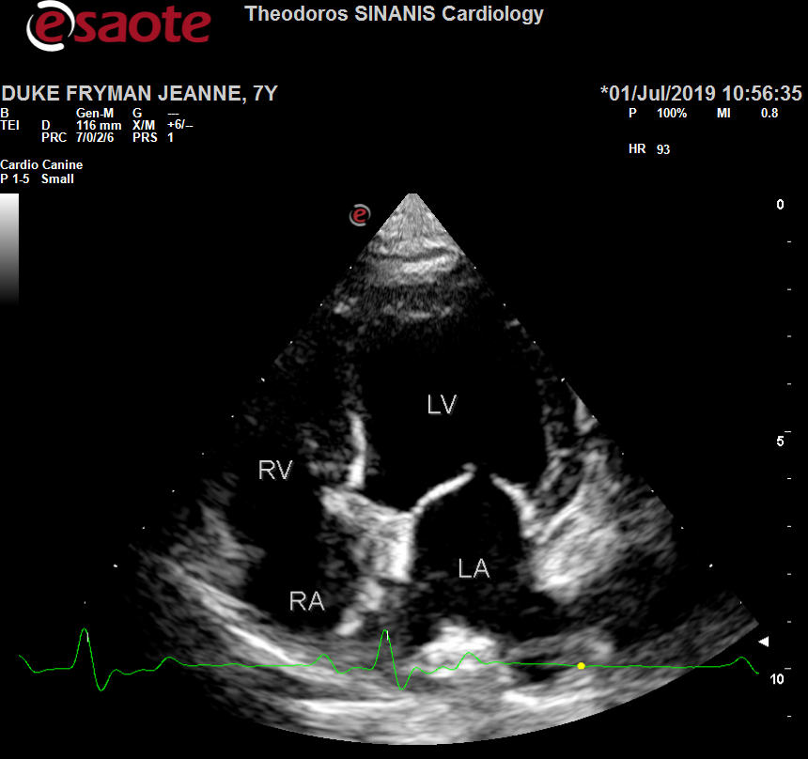 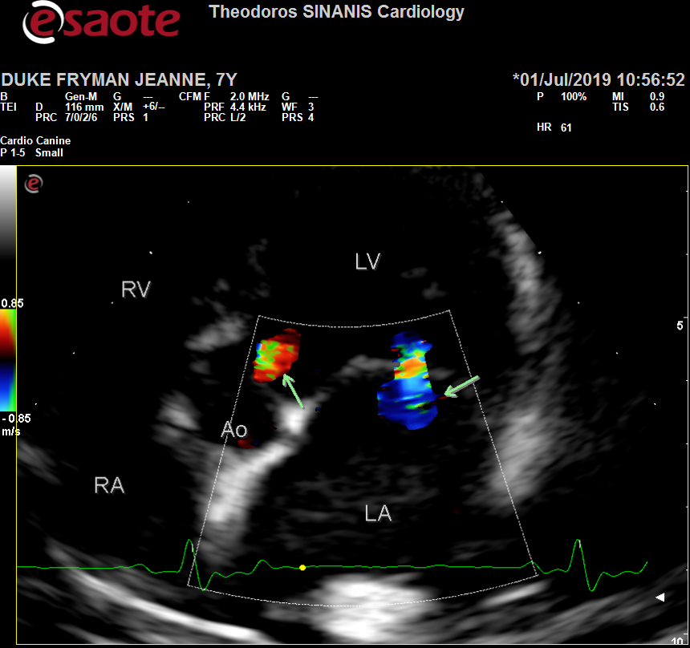

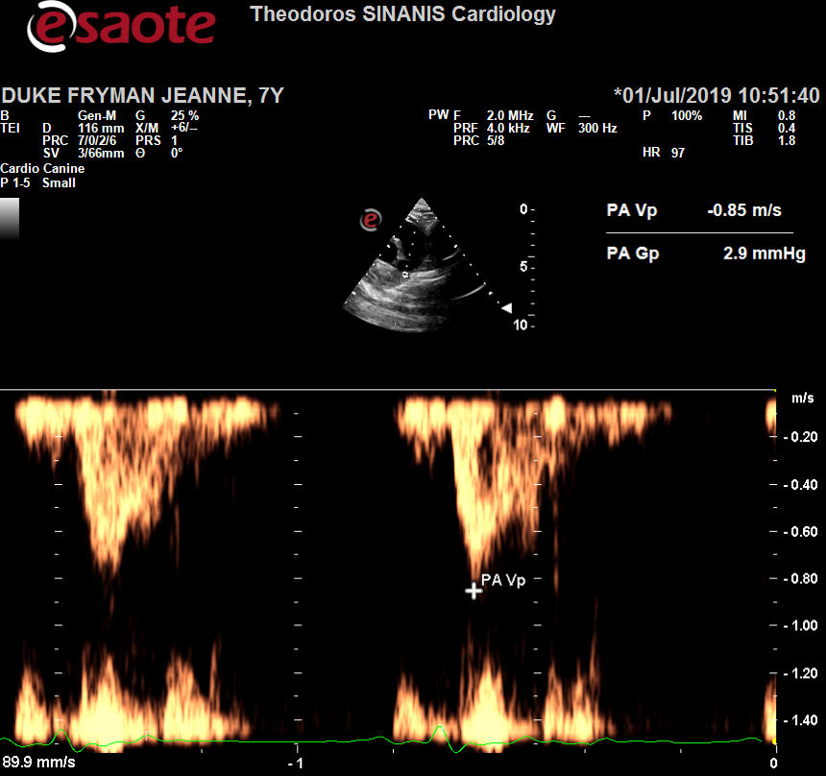 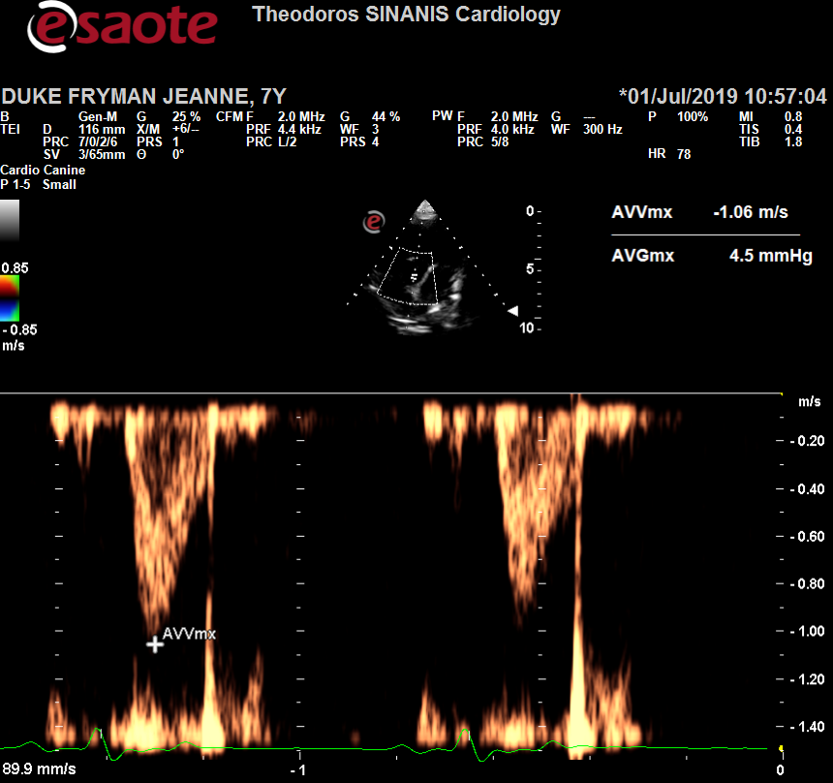

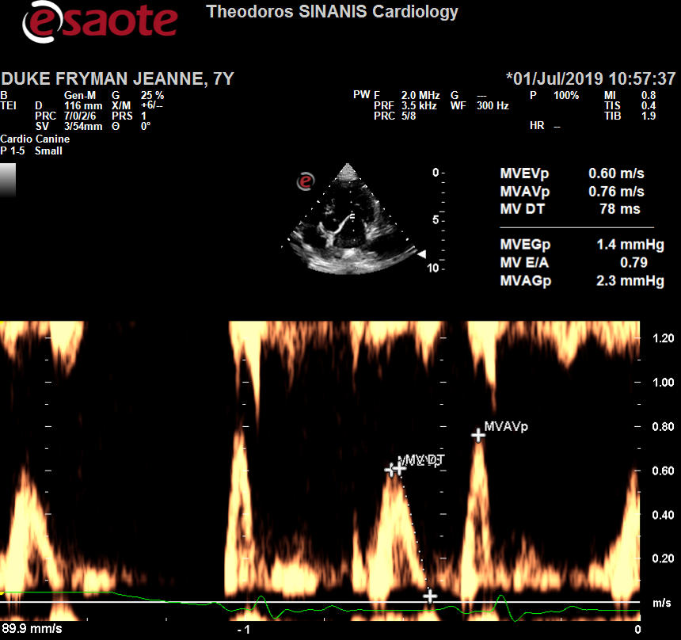 Description: Description: Περιγραφή: Περιγραφή: ac387

Περιγραφή: Περιγραφή: ac387